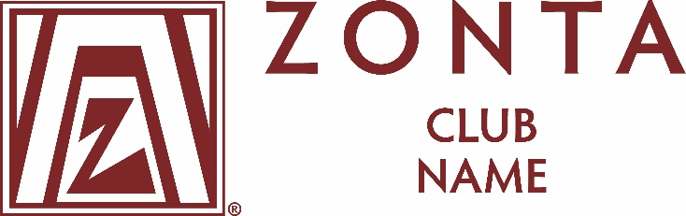

FOR IMMEDIATE RELEASE

Zonta [District # or Zonta Club of]
Zonta Young Women in Leadership Award Recipient Named

TOWN, STATE — DATE— [Recipient’s name] of [city, state/province, country] was named the recipient of the 2025 [Zonta District # or Zonta Club of XX] Young Women in Leadership Award.

The goal of the Zonta Young Women in Leadership Award is to encourage young women to participate in leadership positions by recognizing a young woman’s commitment to the volunteer sector, evidence of volunteer leadership achievements and a dedication to building a better world for women and girls.

Applicants are asked to reflect on their voluntary commitment to their school and their community and the problems limiting the empowerment of women in their own country and worldwide. The Zonta Young Women in Leadership Award program looks to the young women of today for the leaders of tomorrow.

Ms. [Last name of recipient] was named the 2025 [Zonta District # or Zonta Club of XX] Young Women in Leadership Award recipient because [insert reason]. Ms. [Last name of recipient] intends to pursue [academic goals] and to eventually [career goals]. [Insert something from application or biography posted on the Zonta International website such as: She believes women should take measures to realize a more equitable distribution of power between the sexes in government and in all leadership positions.]

Applications for the 2026 Zonta Young Women in Leadership Award will be available in July 2025 at zonta.org/ZontaYoungWomeninLeadershipAwards. Applicants aged 16-19 on April each year, studying at a secondary school, college or university in a Zonta district, or who are studying elsewhere but are citizens of a Zonta country at the time of application, are eligible to apply. The application process must start with a Zonta club and applicants may use the Club Locator to find the nearest Zonta club. Applicants must contact the Zonta club for deadline information.

[Insert paragraph about your Zonta club or district]

Zonta International (www.zonta.org) is a leading global organization of individuals working together to build a better world for women in girls. More than 26,000 members in 64 countries work together to make gender equality a worldwide reality for women and girls. Since 1923, Zonta International has provided more than US$50.9 million to empower women and girls and expand their access to education, health care, economic opportunities and safe living conditions.
Contact:
[Name]
[Title]
Zonta [Club / District / Region]
Phone: [Number]
Email: [Email address]
[Web address]

###

